**MOBILE PROGRAMMING 2 ASSIGNMENT 2.**

**GITHUB LINK:** [**https://github.com/thiira/Mobile-Programming-2-Assignment-2**](https://github.com/thiira/Mobile-Programming-2-Assignment-2)

**BSE-01-0066/2023**

User Interface 1:

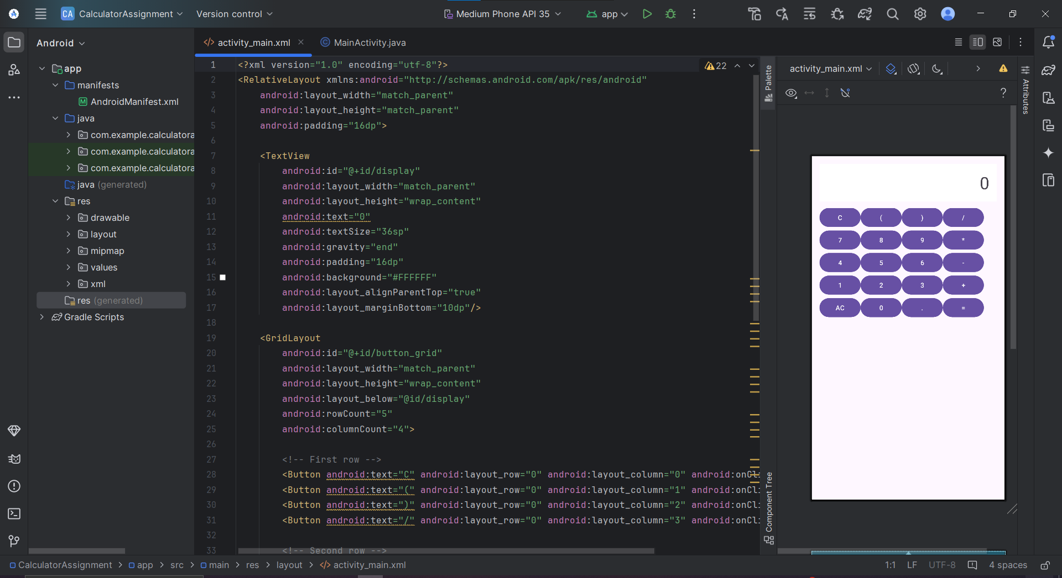

User Interface 2:

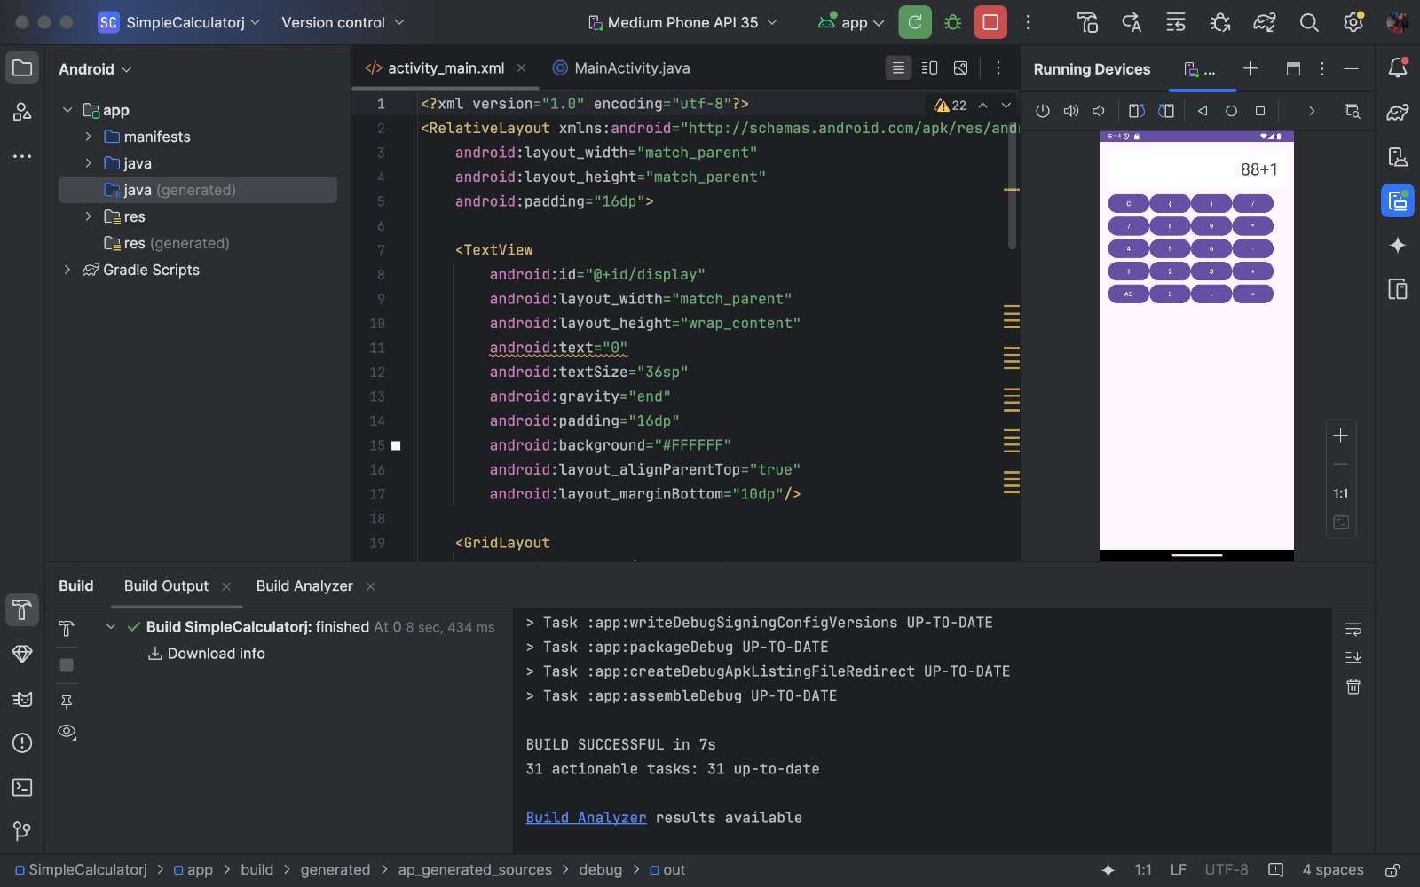

User Interface 3:

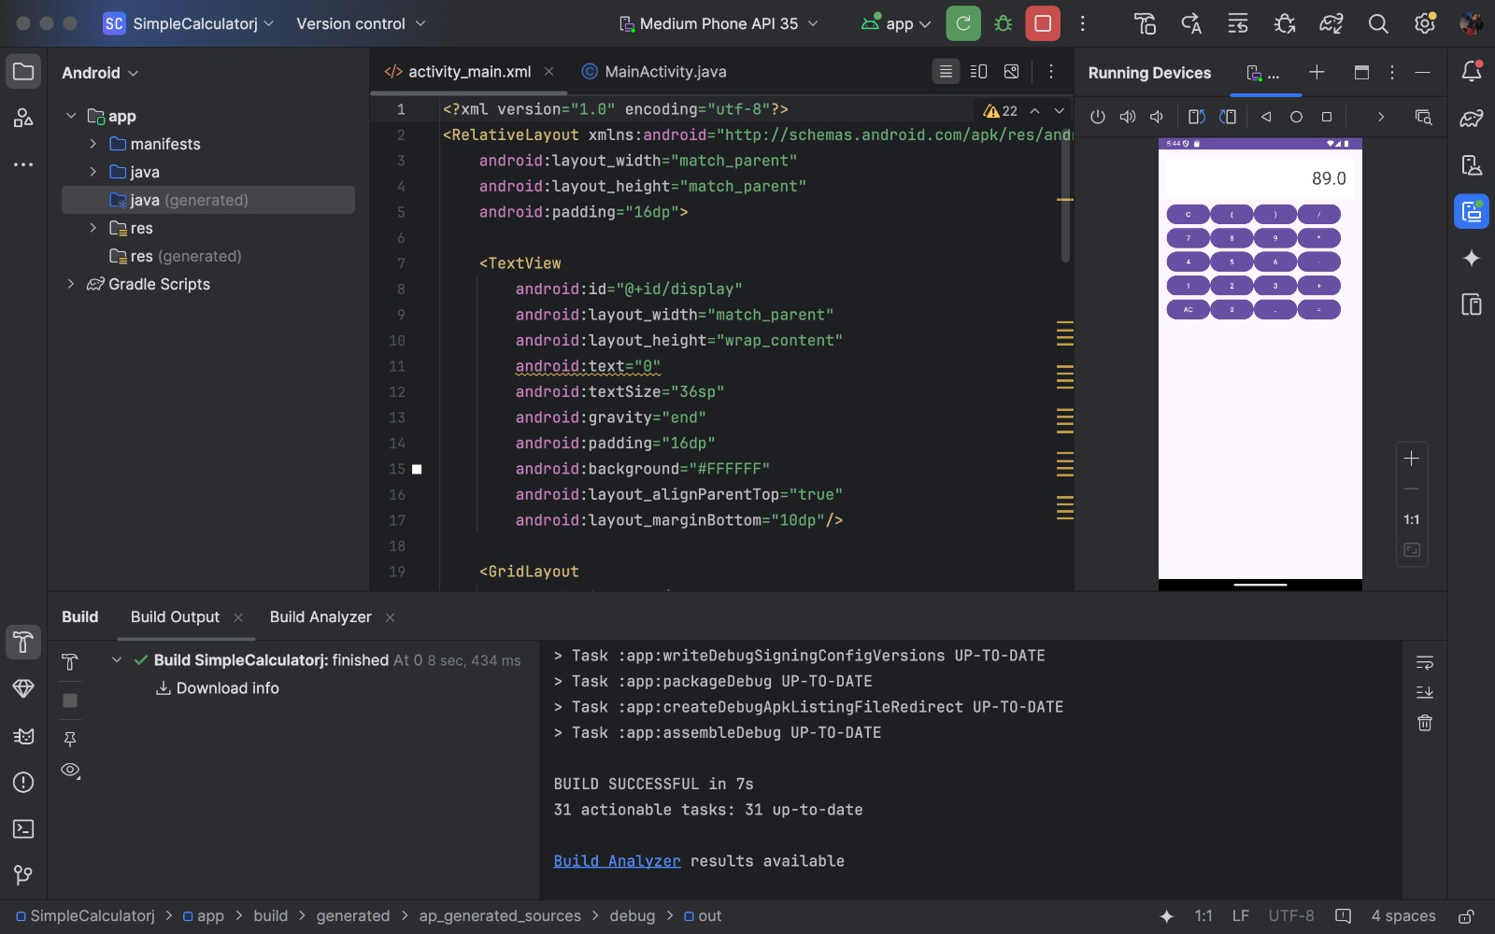

activity_main.xml code snippet:

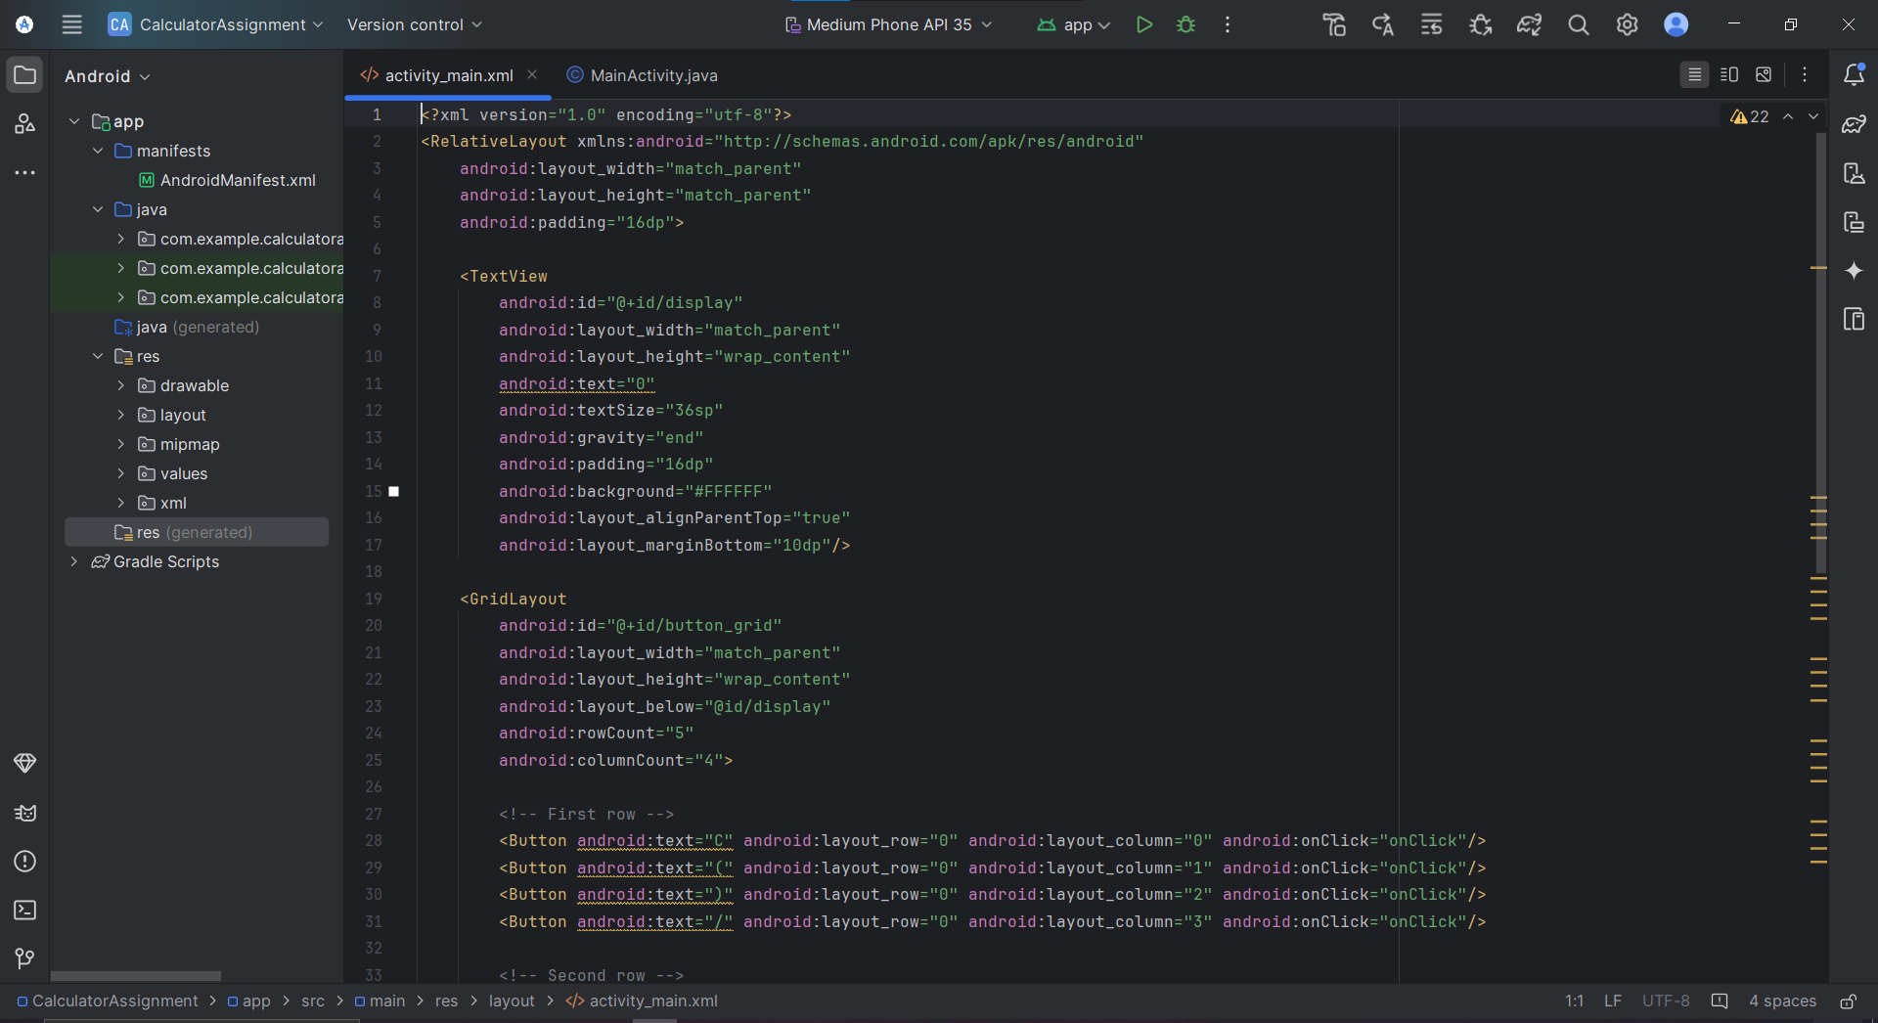

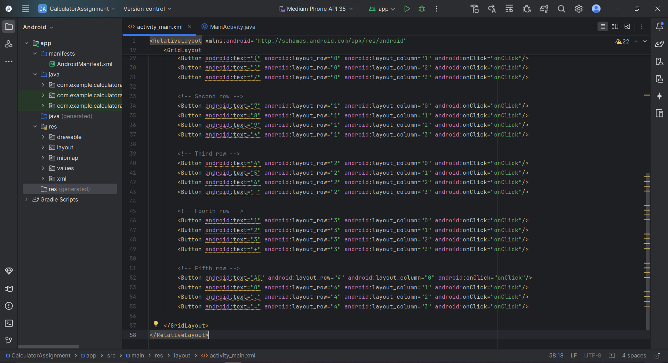

MainActivity.Java Code Snippets:

